CSA1715-ARTIFICIAL INTELLIGENCE
LAB PROGRAM- 16
06-08-2026
16. Write the python program to implement Feed Forward Neural Network.

Aim
To implement a Feed Forward Neural Network (FFNN) using Python for classification. The program trains a neural network using given input features and target values, accepts new input from the user, and predicts the corresponding output.

Algorithm
- Import the MLPClassifier from the Scikit-learn library.
- Define the training input features and their corresponding target values.
- Create a Feed Forward Neural Network with a hidden layer.
- Train the network using the fit() function.
- Accept new input values from the user.
- Pass the input through the trained neural network.
- Use the predict() function to obtain the predicted output.
- Display the predicted class.
Program
from sklearn.neural_network import MLPClassifier

x=[[0,0],[0,1],[1,0],[1,1]]
y=[0,1,1,0]

model=MLPClassifier(hidden_layer_sizes=(4,),max_iter=2000,random_state=1)
model.fit(x,y)

print("Neural Network trained successfully")
a=int(input("Enter first value (0/1): "))
b=int(input("Enter second value (0/1): "))

p=model.predict([[a,b]])
print("Prediction:",p[0])

Input and Output
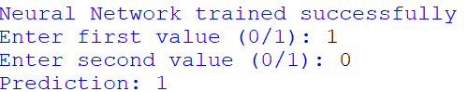

Result:
The Feed Forward Neural Network was successfully implemented using Python. The neural network was trained using the given input features and target values, and it successfully predicted the output for new user-provided input.

